1. ***Power BI Assignemnt***

1.Advantages of natural queries in Power BI are:-

* Sometimes the fastest way to get an answer from the data is to ask a question using natural language. Power BI provides the facility to ask question through natural query.
* When you have submitted the report to the client ,client can search for any query he/she has using this facility provided by Power BI .
* When user type any query , power bi shows all possible predictions ,thus helping user to save time .
* Example



1. The **WFE**cluster manages the initial connection and authentication process for Power BI,using AAD to authenticate clients and provide tokens for subsequent client connections to the Power BI service.

Power BI also uses the **Azure Traffic Manager** (ATM) to direct user traffic to the nearest datacenter, determined by the DNS record of the client attempting to connect, for the authentication process and to download static content and files.

Power BI uses the **Azure Content Delivery Network** (CDN) to efficiently distribute the necessary static content and files to users based on geographical locale.

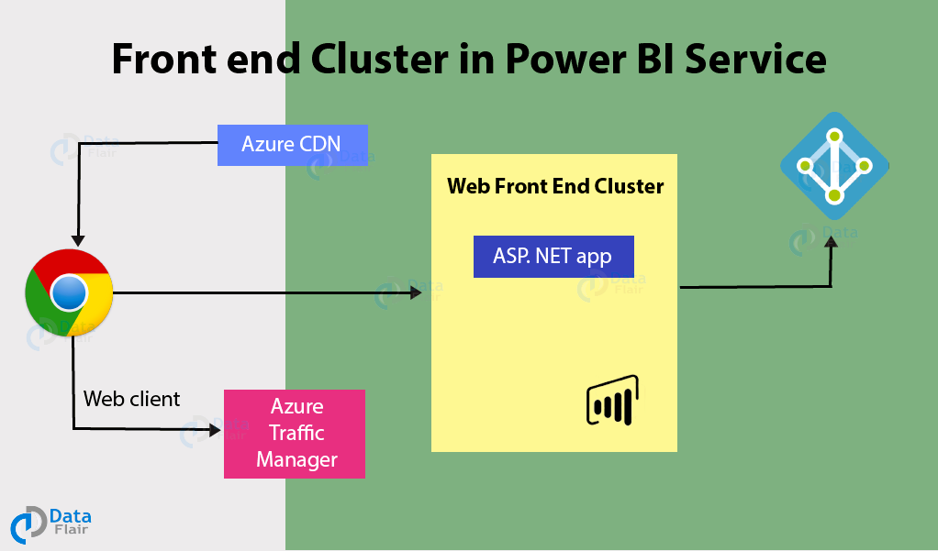

3.The Power BI services at the back end take care of visualizations, datasets, storage, reports, data connections, data refreshing, and other interactions with Power BI.

At the back-end, a web client has only two direct points of interaction, **Azure API Management**, and **Gateway Role**. These two components are responsible for load balancing, authentication, authorization, routing, etc.

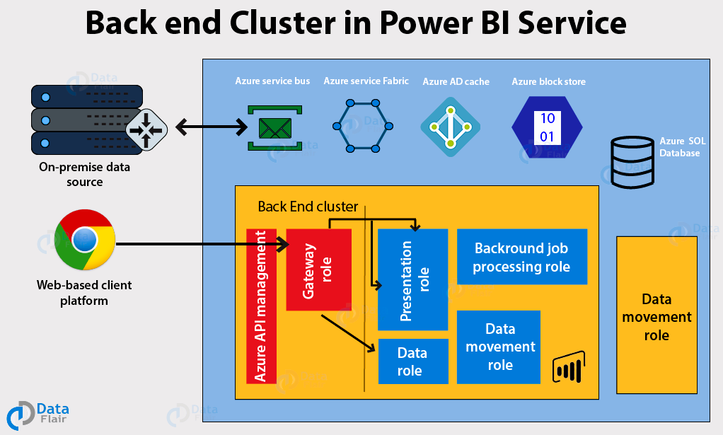

4.ASP.NET component plays a major role while**publishing reports and dashboards** to workspace where stakeholder interact with it in front end provided by Power BI service. Not only that, BI dashboards can also be accessed through other apps like Microsoft teams which embeds BI Applicaiton through ASP.NET framework.

6.Some commonly used data sources in Power BI are:

* Excel
* Text/CSV
* XML
* JSON
* Oracle Database
* IBM DB2 Database
* MySQL Database
* PostgreSQL Database
* Sybase Database
* Teradata Database
* SAP HANA Database
* SAP Business Warehouse server
* Amazon Redshift
* Impala
* Google BigQuery (Beta)
* Azure SQL Database
* Salesforce Reports
* Google Analytics
* Facebook
* GitHub